Home-styler Project Work Documentation

By

Tech Titans

**ACKNOWLEDGEMENT**

We would like to appreciate the Lord, God Almighty for seeing us through the process of executing this project. He has always been extremely faithful.

We also want to thank our parents for their support so far, we pray that the Lord would reward them abundantly. Our sincere gratitude also goes to the entirety of Aptech Computer Education-Abeokuta right from the faculty to our colleagues for their timely professional advice and support.

We appreciate the efforts of everyone that contributed to the success of this project. God bless you all!

Contents

1. Background and Necessity for the Website 4

2. Proposed solution 5

3. Purpose of the document 6

4. Scope of project 7

5. Constraints 8

6. Functional Requirements 9

7. Site Map 10

7.1. Sitemap Example 10

8. Screenshots 12

9. Non-Functional Requirements 15

10. Interface Requirements 16

10.1. Hardware 16

10.2. Software 16

11. Project Deliverables 17

12. Conclusion 18

## Background and Necessity for the Website

As home interiors gain popularity, individuals often feel overwhelmed by design choices, furniture options, and decor elements. A dedicated home interior website provides significant value by:

* **Centralized Platform:** Home-styler acts as a single hub for users to explore designs, accessories, and professional designers without navigating multiple websites.
* **Project Costs Display:** Users can estimate project costs by accessing pricing information for designs and accessories, aiding in budget management.
* **Convenience and Time Savings:** The website serves as a digital space for inspiration and planning, offering diverse design elements from around the world.

## Proposed solution

The solution is the creation of Home-styler, a website that offers a centralized platform for viewing home interior designs and products. Key features include:

* Displaying design images and accessories
* Price listings for various designs
* Search, sort, and filter functionalities
* Profiles of professional interior designers

## Purpose of the document

This document details the Home-styler website's features, interfaces, and operational constraints, aimed at both stakeholders and developers. It serves as a foundational guide for the project's development.

## Scope of project

Home-styler will be a responsive, visually appealing website catering to individuals interested in home interior design. Key features include:

* Visualization and selection of interior design products
* Access to a range of design ideas and professional profiles

## Constraints

The website will not store information on the server. Data will be fetched from TXT files, and users will only view information without any data writing capabilities.

## Functional Requirements

Home-styler will function as a Single-Page Application (SPA) with the following requirements:

1. **Home Page:** Displays a gallery and menu options.
2. **Viewing Design Styles:** Users can browse by category and view associated details.
3. **Professional Designer Gallery:** Details of designers for user contact.
4. **Searching, Sorting, Filtering:** Users can search and filter design elements.
5. **Feedback:** Users can provide feedback via a form (not stored).
6. **Contact Us:** Contact information for creators.
7. **Browsing Products:** Listings categorized by type, including furniture, lighting, decor, kitchen, and bathroom.
8. **User Reviews and Ratings:** Access to product reviews.

## Site Map

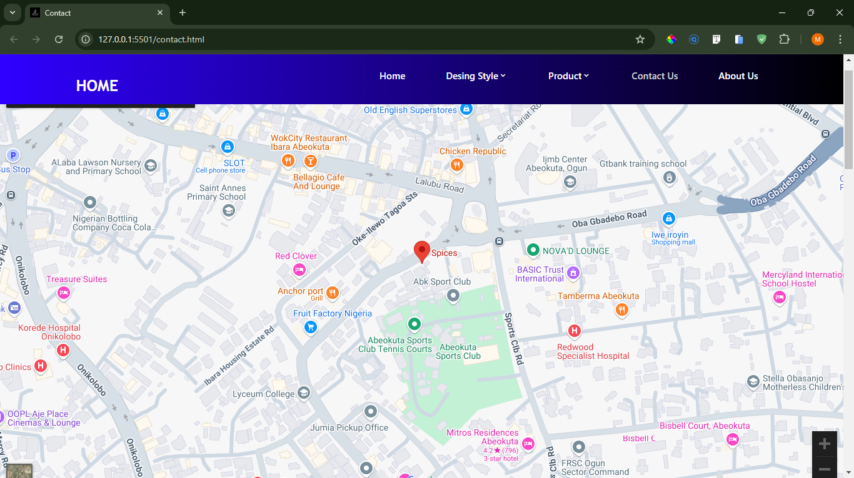

MAP OF OUR SITE

Below is a structure of the navigational flow of objects in the Home-styler website.

As is seen in the figure, the site’s navigation takes a kind of “full mesh” structure. This means that all pages are interlinked.

Each of the pages is linked to every other page on the website and this is achieved through the consistent navigation menu.

* Home
* Design Styles
* Designer Gallery
* Products
* Feedback
* Contact Us
* About Us

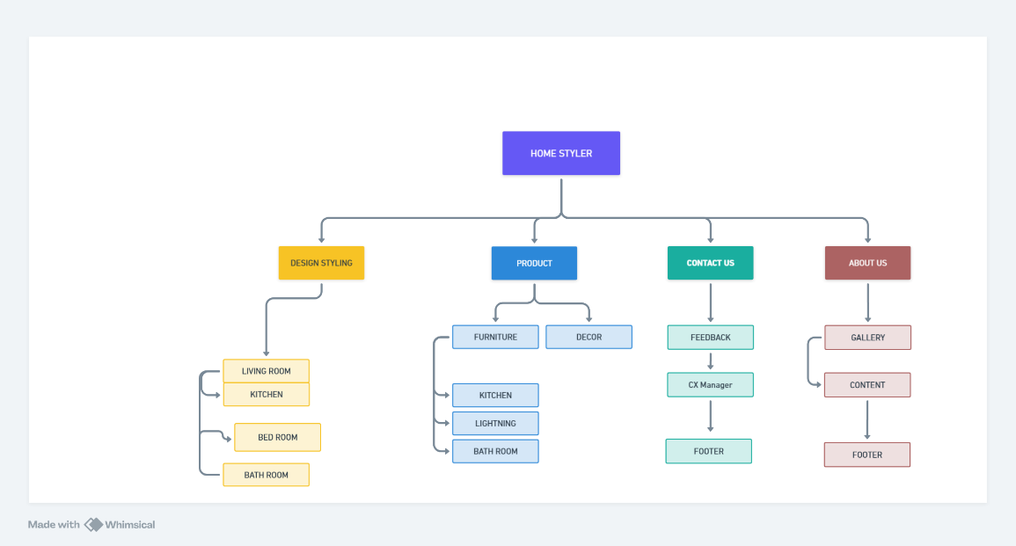

## Screenshots

Nobody needs to be taught how to use the internet but sometimes, it is necessary to familiarize ourselves certain environments. Two sites may have the same aims and objectives but they would surely have different modes of implementation. This is why I have decided to point out some important aspects of **Home styler** website using visuals.

* Navigation menu

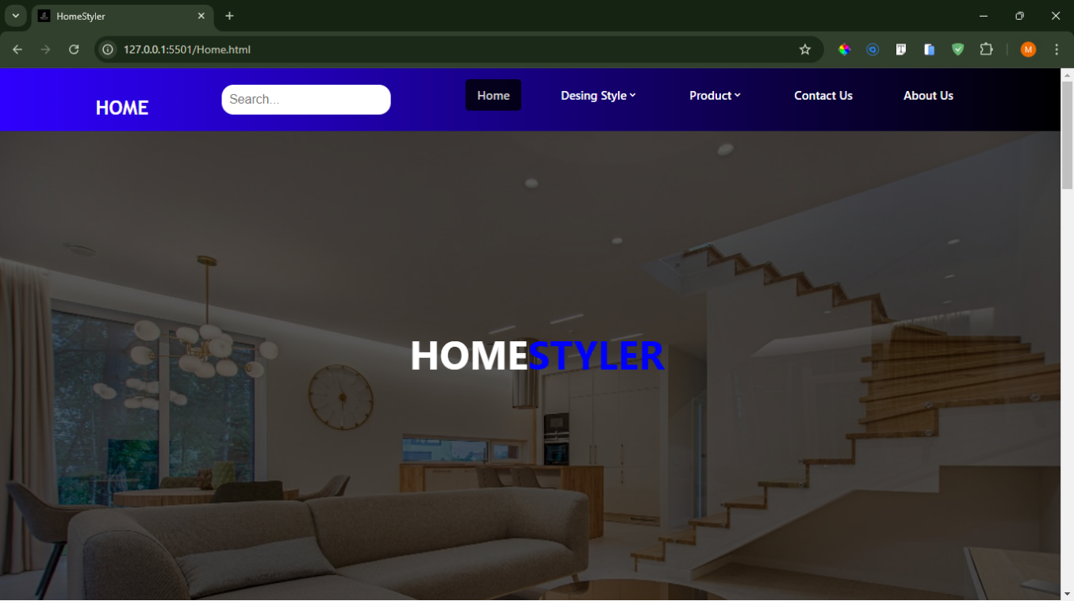

This is a card-like designed navigation located at the top of the page.

* Some part of the product page

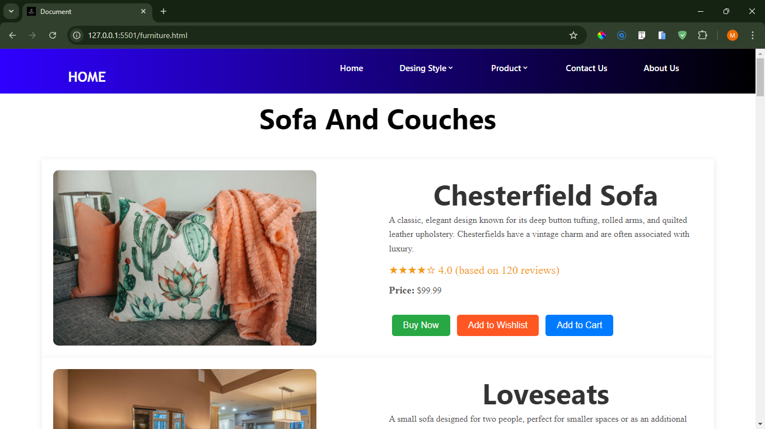

The product page is divided into sections.

* Google Maps



What if there’s need to contact people in charge? There’s absolutely no problem with that as Google maps has been integrated into the website to ease that process!

## Non-Functional Requirements

Key non-functional requirements include:

* **Safety:** No malicious downloads.
* **Accessibility:** Clear fonts and navigation.
* **User-friendliness:** Easy navigation.
* **Operability:** Reliable and efficient performance.
* **Performance:** Minimal load times.
* **Scalability:** Support for concurrent users.
* **Availability:** 24/7 access.
* **Compatibility:** Works across the latest browsers and devices.

## Interface Requirements

### Hardware

* Intel Core i5/i7 Processor
* 8 GB RAM
* 500 GB Hard Disk space
* Mouse and Keyboard

### Software

* **IDE:** Visual Studio Code
* **Frontend Technologies:** HTML5, CSS3, JavaScript, Figma Toolkit, XML
* **Data Store:** TXT

## Project Deliverables

The final submission will include:

* A complete project report covering:
  + Problem Definition
  + Design Specifications
  + Flowcharts and Data Flow Diagrams
  + Installation Instructions
* User Interface designs for Home-styler
* Implementation of core features, including searching and filtering
* Documentation of functionality
* A video demonstration of the website
* Optional live hosted URL

## Conclusion

HomeStyler is designed to simplify the home interior design process by providing a comprehensive platform for inspiration, product selection, and designer engagement. This documentation serves as a guide to ensure all functional and non-functional requirements are met, providing a robust and user-friendly experience.